Directions: Solve the following triangles for all side lengths and all angle measures.
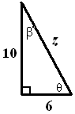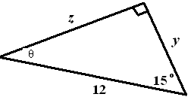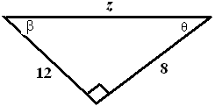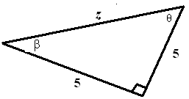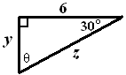

z = _______ y = _______ z = _______ z = _______ y = _______

θ = _______ z = _______ θ = _______ θ = _______ z = _______

β = _______ θ = _______ β = _______ β = _______ θ = _______

You are flying a red kite at an angle of elevation of about 75° holding on to the kite string which is 100m long. Your friend is flying a blue kite. The angle of elevation of your friend’s kite is 60° and he is holding onto a kite string that is 150m long. Determine which kite is flying higher in the sky. How much higher is it flying?

How much higher does a 6m ladder reach on a wall when placed at a 70° angle compared to
when it is placed at a 60° angle? (see figure to the right)

When the suns angle of elevation is 57° a building casts a shadow that is 21m long.
How tall is the building?

